STEP 1 – Main Terrain file with GM (Global Mapper)
1.1-) Define your terrain region and go to the internet and download a SRTM30 data. A good site for it is:
http://www.webgis.com/srtm30.html
Select the regions of your interest – download only the .dem.zip format of each region chosen. Put SRTM30 data on your working dir. If you want to download all entire world data files, make a special directory for it. Do not extract the zip files. GM can open its zipped.
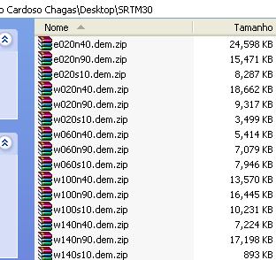
1.2-) Start the Global Mapper. Open your .dem.zip files. The GM will positioning any file on correct positioning using latitude zero and longitude zero reference. (Try to open 4 consecutive or more .dem.zip files to see). On GM start window, choose OPEN YOUR OWN DATA FILES. For these tutorial only open w020n40, w060n40, w020n90 and w060n90 for a good visualization on where Azores Islands are (near the middle of North Atlantic Ocean). This region was used for this tutorial. Note that height scale, on the left, have some negative values.
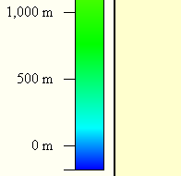
TIP: GM can generate a selection intersecting various regions files and generate a new file limited by the selection.
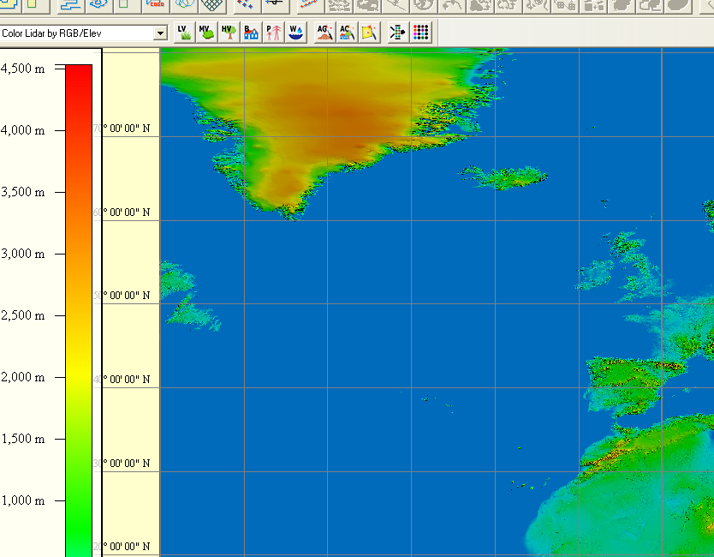
1.3-) We need to eliminate negative height values. Export a new selection like BIL file type, and save into a new file:
-FILE –EXPORT-EXPORT ELEVATION GRID FORMAT – Select BIL/BIP/BSQ File – Click OK
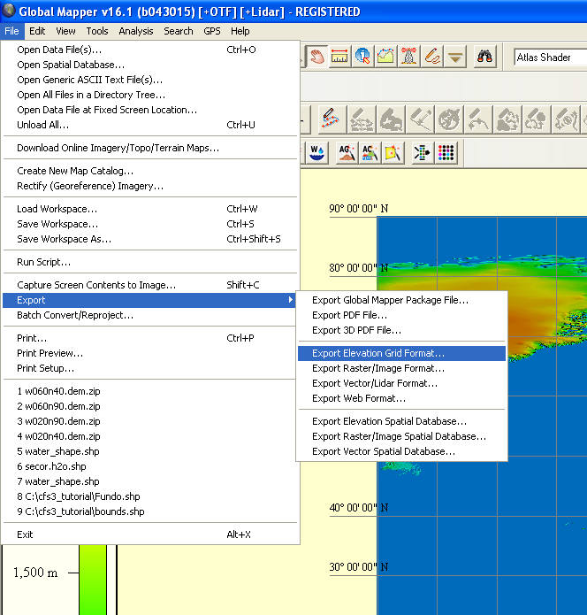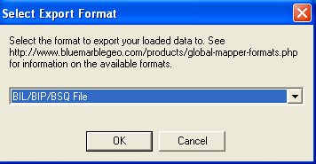

Click OK on Tip window.
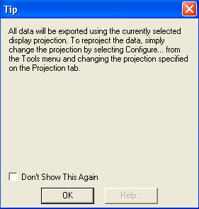
Select options on Options tab like next image, after this select EXPORT BOUNDS tab
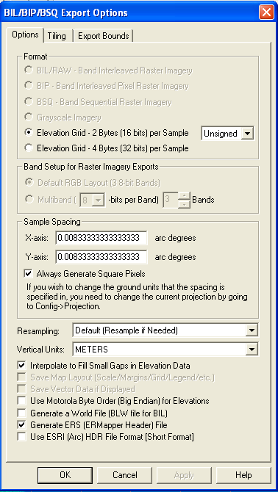
The UNSIGNED option will remove all negative values.
The ERS header file will be used by ERS2TIFF command.
On EXPORT BOUNDS tab select the small area (move BIL/BIP/BSQ Export Options window to right side).
Enable “Lat/Lon (Degrees)” and write edit boxes like next image. Click OK
TIP: You can see the selection modification according you changes the edit boxes coordinates values.
ADVICE: YOU MUST TO GENERATE A SQUARE SCENERY WITH MULTIPLE OF 256 EDGE (Use the ref. table on CFS3_Math.xls. For this tutorial I used 768x768 BIL file size. Use N 41.39, W -31.39, S 35 and E -25
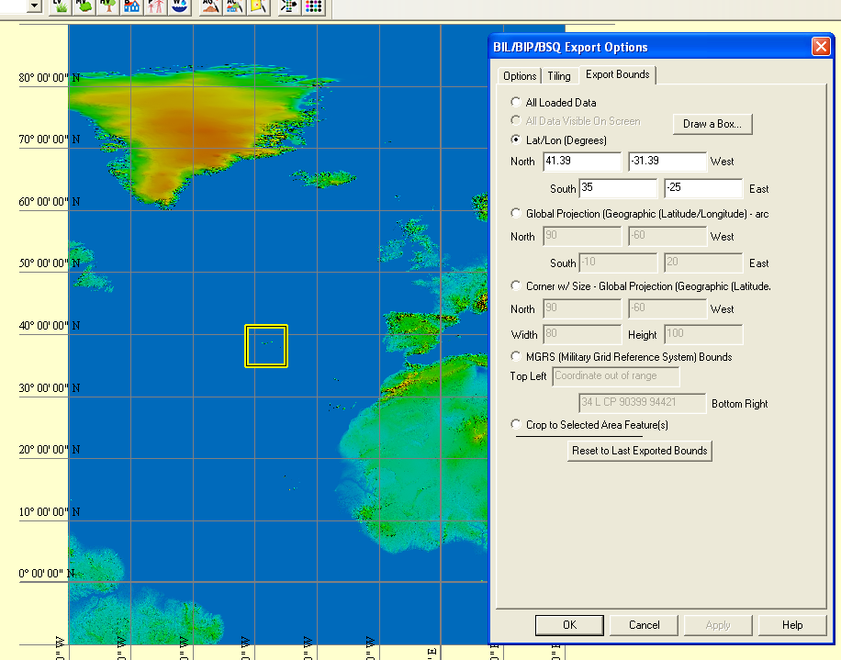
To save it, name your selected area like RAW and save it on your working dir.
1.4-) Returning to GM, close all data: FILE – UNLOAD ALL…
1.5-) Let´s see raw.bil generated: OPEN YOUR OWN DATA FILES – Select raw.bil. Note: No negative values
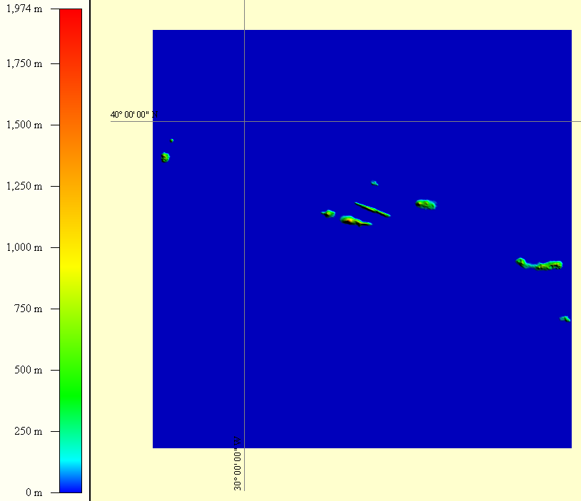
No negative values

1.6-) GM generated 4 files: only raw.bil and raw.ers files are needed for CFS3 SCENERY. Delete the others. Minimize the GM window to see the generated files.
1.7-) Open file raw.ers with the Notepad and check it, the BIL file generated has 768x768 pixels – It´s a SQUARE. For CFS3 Scenery, you must to generate SQUARE Scenery with an edge multiple of 256.
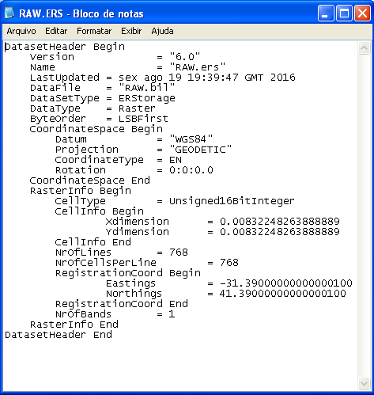
768 is multiple of 256. 768x768 is a square.
After check, close raw.ers.
1.8-) Now, you have the main file adjusted to generate all files for next steps. Don´t save any modification on your raw.bil on next steps. Keep it unmodified. Check your working dir.
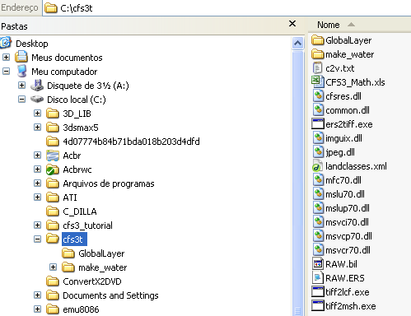

1.9-) END OF STEP 1

